**DIGITAL MARKETING**

# ASSIGNMENT

|  |  |
| --- | --- |
| Reg No | 960220106099 |
| Team ID | NM2023TMID02691 |
| NM ID | EE45EEEDDA81E7DA4A8419AF9DDD8288 |
| Date | 21-10-2023 |

1. Create a blog or website using blogspot and wordpress. Customize the theme design and post new article with 500 words

Blog Link:

<https://www.blogger.com/blog/posts/3513838784799052442>

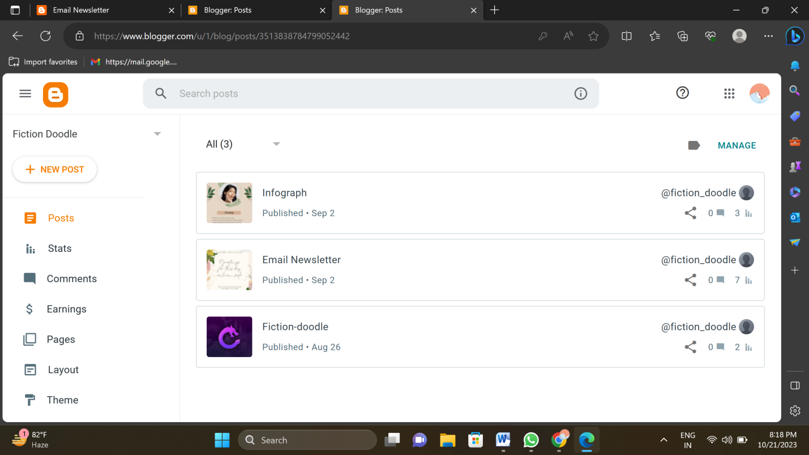

Word Press:

<https://sobirunthav24.wordpress.com/2023/10/13/foodfly/>

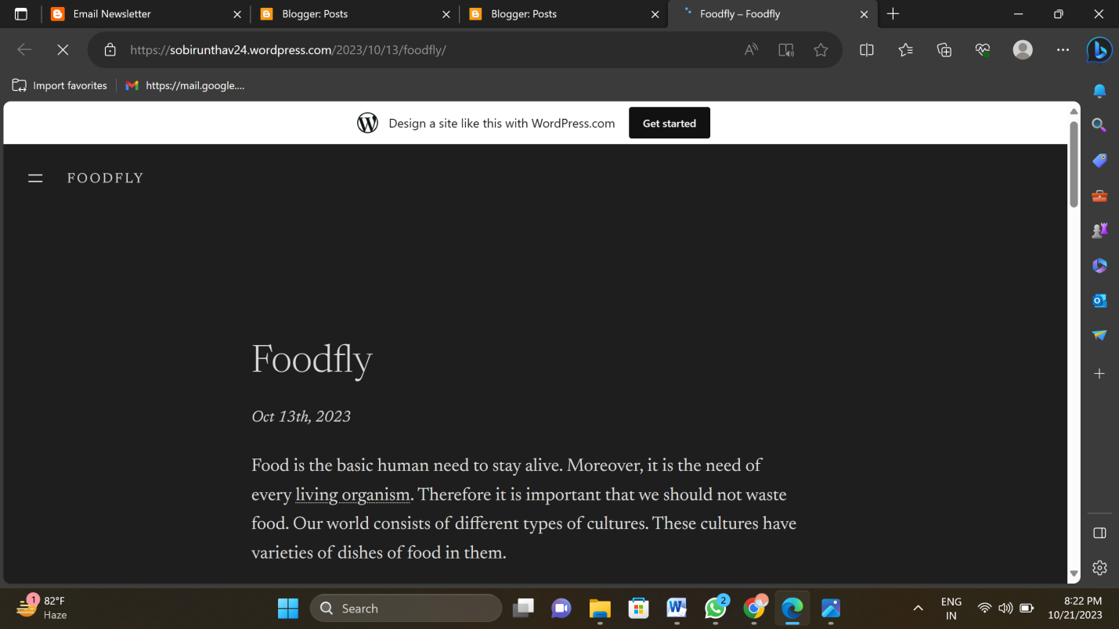

2. Create a New Facebook Business Page and post one social media poster for your brand

Facebook Business Page Link:

<https://www.facebook.com/profile.php?id=61550755460620&mibextid=ZbWKwL>

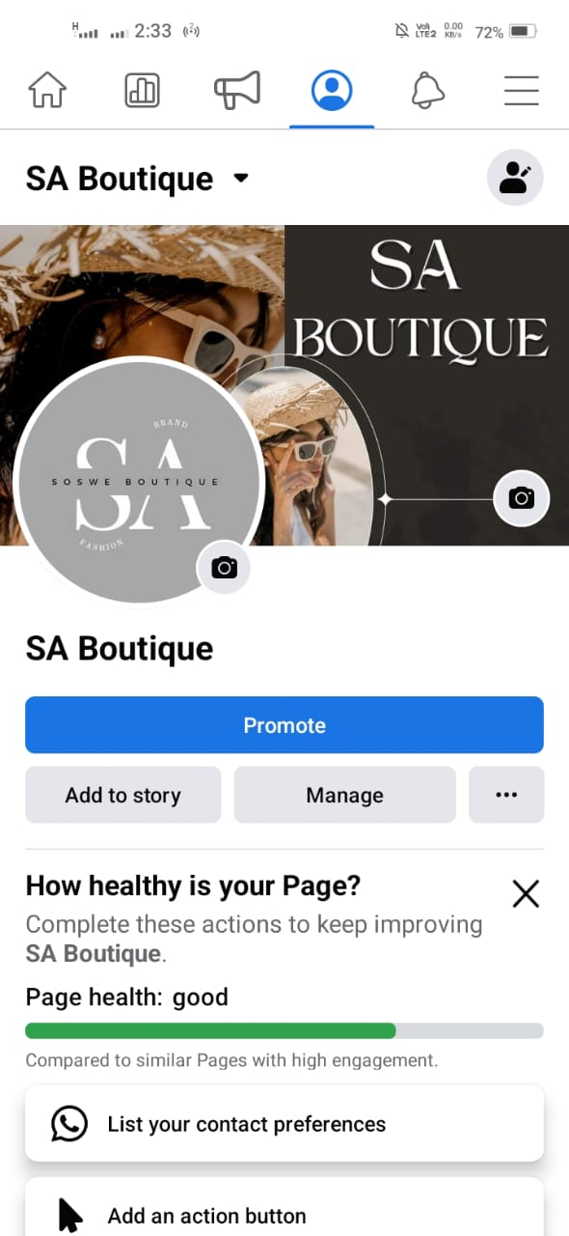

**3. Create and design a social media advertisement poster using canva**

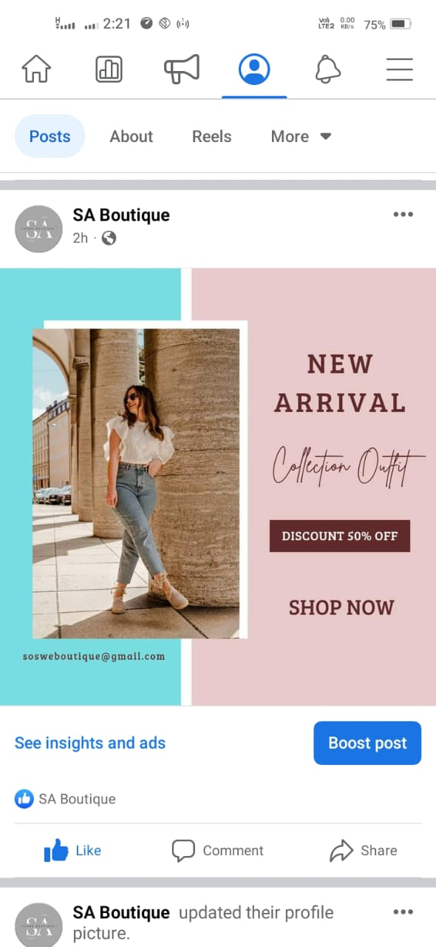

**4. Create email newsletter design using mailchimp or canva**

Email newsletter Link:

<http://fiction-doodle.blogspot.com/2023/09/email-newsletter.html>

